Predicting hourly boarding demand of bus passengers using imbalanced records from smart-cards: A deep learning approach
1. INTRODUCTION
We acknowledge the financial support from the National Natural Science Foundation of China (Project No. 71890972/71890970). Tianli Tang is supported by the Key Project of National Natural Science Foundation of China (No. 52131203) and the project of Jiangsu Funding Program for Excellent Postdoctoral Talent. Charisma Choudhury acknowledges the financial support of her UKRI Future Leader Fellowship, UK [MR/T020423/1- NEXUS]. Yuanyuan Wang is supported by the Natural Science Foundation of Zhejiang Province (LQ18G030012), the Humanities and Social Sciences Fund of the Ministry of Education (18YJC630190). The authors would also like to thank Hunan Longxiang Bus Co., Ltd. for providing the smart-card data for this study and . T. Tang is with the School of Transportation, Southeast University, Nanjing, 211189, China (email: T-Tang@seu.edu.cn). R. Liu and C. Choudhury are with the Institute for Transport Studies, University of Leeds, Leeds, LS2 9JT, United Kingdom (emails: R.Liu@its.leeds.ac.uk, C.F.Choudhury@leeds.ac.uk) A. Fonzone is with the Transport Research Institute, Edinburgh Napier University, Edinburgh, EH10 5DT, United Kingdom (emails: a.fonzone@napier.ac.uk) Y. Wang is with the School of Business Administration, Zhejiang University of Finance and Economics, Hangzhou, 310018, China (emails: wangyuan@zufe.edu.cn) * Corresponding author. Email: R.Liu@its.leeds.ac.uk. T HE rapid progress of urbanization leads to expansion of population in the urban area, increased demand for travel and associated adverse effects in traffic congestion and air pollution. Public transport has been widely recognised as a green and sustainable mode of transportation to relieve such transport problems. As a conventional public transport mode, buses have always played a dominant role in passenger transportation. However, unreliable travel time, bus-bunching and crowding have led to low level-of services for buses. This has decreased the bus ridership in many cities, particularly with the advent of ride-hailing services in recent years .To sustain and increase bus patronage, bus operators must find a way to improve its performance and enhance its image and attraction. Advanced operation and management for bus systems can significantly improve the level-of-service and service reliability, which in turn helps increase the bus ridership. This requires understanding the spatial and temporal variations in passenger demand and making necessary changes on the supply side. The smart-card system is initially designed for automatic fare collection. As the system also records the boarding information, for example, who gets on buses, where and when, smart-card data has become a ready-made and valuable data source for spatio-temporal demand analysis public transport planning and further analysis of emission reduction for the sustainable transport. From the smart-card data, we can easily observe the passenger flow at bus stops and on bus lines, and from which to derive the spatial and temporal characteristics of bus trips. However, extracting useful information from big data automatically still poses a significant challenge. In recent years, machine learning techniques have emerged as an efficient and effective approach to analyzing large smart-card datasets. For instance, Liu et al. captured key features in public transport passenger flow prediction via a decision tree model. Zuo et al.built a three-stage framework with a neural network model to forecast the individual accessibility in bus systems. In our own recent research we demonstrate that smartcard data combined with machine learning techniques can be a powerful approach for predicting the spatial and temporal patterns of bus boarding. The predictions were found to be highly accurate at an aggregated level, averaged over all travellers. However, our research has also thrown light on the data imbalance issues, when trying to predict travel behavior at the level of individual travellers and fine spatial-temporal details. For instance, the boarding of an individual smart-card holder at a specific stop during a particular time window (e.g. an hour) is a rare event: most of the records would denote negative (non-travelling, or not boarding at this bus stop during this time window) instances, and only a few are positive (travelling, boarding at this stop at this time) instances. Such data imbalance issues can significantly reduce the efficiency and accuracy of machine learning models deployed for predicting travel behaviour at the level of individual travellers and fine spatial-temporal details. This motivates this current study where we propose an over-sampling method, deep generative adversarial nets (Deep-GAN) model (initially developed in the context of image generation) to address the data imbalance issue in predicting disaggregate boarding demand (i.e. individual passengers boarding behavior during each hour of the day). We show that, with the synthesized and more balanced database, the prediction accuracy improves significantly. The performance of the proposed approach, based on the Deep GAN method, is further benchmarked against other resampling methods (including Synthetic Minority Oversampling Technique and Random Under-Sampling) and is shown to have superior performance. The rest of the paper is organized as follows. Section II reviews the key resampling methods and their applications in transport studies. Section III describes the specific data imbalance issue in predicting the hourly boarding demand. Section IV uses a Deep-GAN to provide a synthesized, more balanced training data sample and a deep neural network (DNN) to predict the individual smart-card holders’ boarding actions (boarding or not boarding) in any hour of a day. Section V applies the proposed method to a real-world case study, and the results are discussed in Section VI. Finally, Section VII summarizes the main findings and contributions of this paper and suggests future investigations.
1.1 Objective of the project:
The tap-on smart-card data provides a valuable source to learn passengers’ boarding behaviour and predict future travel demand. However, when examining the smart-card records (or instances) by the time of day and by boarding stops, the positive instances (i.e. boarding at a specific bus stop at a specific time) are rare compared to negative instances (not boarding at that bus stop at that time). Imbalanced data has been demonstrated to significantly reduce the accuracy of machine learning models deployed for predicting hourly boarding numbers from a particular location. This paper addresses this data imbalance issue in the smart-card data before applying it to predict bus boarding demand. We propose the deep generative adversarial nets (Deep-GAN) to generate dummy travelling instances to add to a synthetic training dataset with more balanced travelling and non-travelling instances. The synthetic dataset is then used to train a deep neural network (DNN) for predicting the travelling and non-travelling instances from a particular stop in a given time window. The results show that addressing the data imbalance issue can significantly improve the predictive model’s performance and better fit ridership’s actual profile. Comparing the performance of the Deep-GAN with other traditional resampling methods shows that the proposed method can produce a synthetic training dataset with a higher similarity and diversity and, thus, a stronger prediction power. The paper highlights the significance and provides practical guidance in improving the data quality and model performance on travel behaviour prediction and individual travel behaviour analysis.
2. LITERATURE SURVEY:
“Timetable coordination of first trains in urban railway network: A case study of beijing,”
A model of timetable coordination of first trains in urban railway networks, based on the importance of lines and transfer stations, is proposed in this paper. A sub-network connection method is developed, and a mathematical programming solver is utilized to solve the suggested model. A simple test network and a real network of Beijing urban railway network are modelled to verify the effectiveness of our suggested model. Results demonstrate that the proposed model is effective in improving the transfer performance in that they reduce the connection time significantly.
“Predicting peak load of bus routes with supply optimization and scaled shepard interpolation: A newsvendor model,”
The level of service on public transit routes is very much affected by the frequency and vehicle capacity. The combined values of these variables contribute to the costs associated with route operations as well as the costs associated with passenger comfort, such as waiting and overcrowding. The new approach to the problem that we introduce combines both passenger and operator costs within a generalized newsvendor model. From the passenger perspective, waiting and overcrowding costs are used; from the operator’s perspective, the costs are related to vehicle size, empty seats, and lost sales. Maximal passenger average waiting time as well as maximal vehicle capacity are considered as constraints that are imposed by the regulator to assure a minimal public transit service level or in order to comply with other regulatory considerations. The advantages of the newsvendor model are that (a) costs are treated as shortages (overcrowding) and surpluses (empty seats); (b) the model presents simultaneous optimal results for both frequency and vehicle size; (c) an efficient and fast algorithm is developed; and (d) the model assumes stochastic demand, and is not restricted to a specific distribution. We demonstrate the usefulness of the model through a case study and sensitivity analysis.
“Artificial intelligence in railway transport: Taxonomy, regulations and applications,”
Artificial Intelligence (AI) is becoming pervasive in most engineering domains, and railway transport is no exception. However, due to the plethora of different new terms and meanings associated with them, there is a risk that railway practitioners, as several other categories, will get lost in those ambiguities and fuzzy boundaries, and hence fail to catch the real opportunities and potential of machine learning, artificial vision, and big data analytics, just to name a few of the most promising approaches connected to AI. The scope of this paper is to introduce the basic concepts and possible applications of AI to railway academics and practitioners. To that aim, this paper presents a structured taxonomy to guide researchers and practitioners to understand AI techniques, research fields, disciplines, and applications, both in general terms and in close connection with railway applications such as autonomous driving, maintenance, and traffic management. The important aspects of ethics and explain ability of AI in railways are also introduced. The connection between AI concepts and railway sub domains has been supported by relevant research addressing existing and planned applications in order to provide some pointers to promising directions.
“A review on co-benefits of mass public transportation in climate change mitigation,”
The magnitude of co-benefits from policy targeting climate change mitigations has been widely promoted due to the desirable win-win results of such policies towards both local and global targets. This review looks at studies on quantitative environmental and health co-benefits from various modal shifts to public transport scenarios. A systematic review was conducted to evaluate publications from 2004 to August 2015. A total of 153 articles were identified and 9 articles fulfilled all the criteria in this review. Many studies that have been done merely focused on the environmental benefits, especially on reduced air pollution from public transport in cities.
“Bus od matrix reconstruction based on clustering wi-fi probe data,”
The estimation of citywide passenger demand plays a vital role in system planning, operation, and management of the urban transit system. The Wi-Fi probe data, one of the emerging crowd sourcing data, is utilized to collect traces of smart phone users in this study. We establish a framework for OD matrix reconstruction, including extracting features for transit patronage and distinguishing them from non-transit users based on K-means clustering. Such a framework makes partial OD matrix more reliable. A probabilistic estimation method of bus OD matrix reconstruction is then proposed based on the partial OD matrix and the number of boarding and alighting passengers. A field study was carried out on bus line 5 in Suzhou, China. Compared to the measured ground truth, the difference in OD-level is 0.5–1.5 passengers per stop, showing that the proposed method for OD matrix reconstruction is reliable.
“A real-time bus dispatching policy to minimize passenger wait on a high frequency route,”
One of the greatest problems facing transit agencies that operate high-frequency routes is maintaining stable headways and avoiding bus bunching. In this work, a real-time holding mechanism is proposed to dispatch buses on a loop-shaped route using real-time information. Holds are applied at one or several control points to minimize passenger waiting time while maintaining the highest possible frequency, i.e. using no buffer time. The bus dispatching problem is formulated as a stochastic decision process. The optimality equations are derived and the optimal holding policy is found by backward induction. A control method that requires much less information and that closely approximates the optimal dispatching policy is found. A simulation assuming stochastic operating conditions and unstable headway dynamics is performed to assess the expected average waiting time of passengers at stations. The proposed control strategy is found to provide lower passenger waiting time and better resiliency than methods used in practice and recommended in the literature.
“A model of bus bunching ¨ under reliability-based passenger arrival patterns,”
If bus service departure times are not completely unknown to the passengers, non-uniform passenger arrival patterns can be expected. We propose that passengers decide their arrival time at stops based on a continuous logit model that considers the risk of missing services. Expected passenger waiting times are derived in a bus system that allows also for overtaking between bus services. We then propose an algorithm to derive the dwell time of subsequent buses serving a stop in order to illustrate when bus bunching might occur. We show that non-uniform arrival patterns can significantly influence the bus bunching process. With case studies we find that, even without exogenous delay, bunching can arise when the boarding rate is insufficient given the level of overall demand. Further, in case of exogenous delay, non-uniform arrivals can either worsen or improve the bunching conditions, depending on the level of delay. We conclude that therefore such effects should be considered when service control measures are discussed.
3. SYSTEM ANALYSIS
3.1 EXISTING SYSTEM:
Smart card data has emerged in recent years and provide a comprehensive, and cheap source of information for planning and managing public transport systems. This paper presents a multi-stage machine learning framework to predict passengers’ boarding stops using smart card data.
The framework addresses the challenges arising from the imbalanced nature of the data (e.g. many non-travelling data) and the ‘many-class’ issues (e.g. many possible boarding stops) by decomposing the prediction of hourly ridership into three stages: whether to travel or not in that one-hour time slot, which bus line to use, and at which stop to board. A simple neural network architecture, fully connected networks (FCN), and two deep learning architectures, recurrent neural networks (RNN) and long short-term memory networks (LSTM) are implemented. The proposed approach is applied to a real-life bus network.
We show that the data imbalance has a profound impact on the accuracy of prediction at individual level. At aggregated level, FCN is able to accurately predict the rideship at individual stops, it is poor at capturing the temporal distribution of ridership. RNN and LSTM are able to measure the temporal distribution but lack the ability to capture the spatial distribution through bus lines.
Disadvantages:
• The data generated by SMOTE and ADASYN are susceptible to outliers. They may generate some data in the majority data space due to minority outlier instances (usually noisy data), causing blurred classification borderlines and making the learning difficulties of the classification model.
• The under-sampling methods usually have to pay the price of losing parts of the information of the majority of data because they have to remove a part of the data. Although the Easy Ensemble and Balance Cascade tried to solve the problem of lost information, they increased the number of models tens of times, significantly increasing the computational burden.
• Little study has noticed the loss caused by the data imbalance issue in the public transport system. There is also no research to validate the efficiency of the existing resampling methods on imbalanced data in the boarding prediction task.
3.2 PROPOSED SYSTEM:
• The data imbalance issue in the public transport system has received little attention, and this study is the first to focus on this issue and propose a deep learning approach, Deep-GAN, to solve it.
• This study compared the differences in similarity and diversity between the real and synthetic travelling instanced generated from Deep-GAN and other over-sampling methods. It also compared different resampling methods for the improvement of data quality by evaluating the performance of the next travel behaviour prediction model. This is the first validation and evaluation of the performance of different data resampling methods based on real data in the public transport system.
• This paper innovatively modelled individual boarding behaviour, which is uncommon in other travel demand prediction tasks. Compared to the popular aggregated prediction, this individual-based model is able to provide more details on the passengers’ behaviour, and the results will benefit the analysis of the similarities and heterogeneities.
Advantages
- The system proposes an over-sampling method, deep generative adversarial nets (Deep-GAN) model (initially developed in the context of image generation) to address the data imbalance issue in predicting disaggregate boarding demand (i.e. individual passengers boarding behavior during each hour of the day).
- The system shows that, with the synthesized and more balanced database, the prediction accuracy improves significantly. The performance of the proposed approach, based on the Deep- GAN method, is further benchmarked against other resampling methods (including Synthetic Minority Oversampling Technique and Random Under-Sampling) and is shown to have superior performance.
Extension Concept
In propose paper author has used traditional DNN algorithm so as extension we have utilized CNN2D (convolution neural network 2 Dimension) algorithm. CNN2D known for data optimization using multiple neurons so its prediction accuracy will be high with more optimized features.
Modules:
To implement this project we have designed following modules as web application
- User Login: user can login to system using username and password as admin and admin
- Process Dataset: this module will load dataset and then normalize, clean and apply DCGAN to handle imbalance issue
- Existing Smote: process dataset will be run with SMOTE algorithm and then test accuracy with test data
- Propose Deep-GAN DNN: DNN algorithm get trained on DEEP GAN generated data and then calculate accuracy on test data
- Extension Deep-GAN CNN2D: CNN2D algorithm get trained on DEEP GAN gene rated data and then calculate prediction accuracy
- Comparison Graph: will plot comparison graph between all algorithms and then display number of test data boarding and predicted boarding.

3.3. PROCESS MODEL USED WITH JUSTIFICATION
SDLC (Umbrella Model):
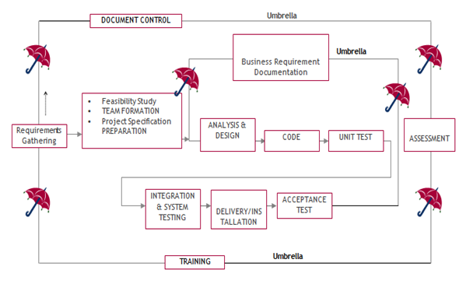
SDLC is nothing but Software Development Life Cycle. It is a standard which is used by software industry to develop good software.
Stages in SDLC:
- Requirement Gathering
- Analysis
- Designing
- Coding
- Testing
- Maintenance
Requirements Gathering stage:
The requirements gathering process takes as its input the goals identified in the high-level requirements section of the project plan. Each goal will be refined into a set of one or more requirements. These requirements define the major functions of the intended application, define operational data areas and reference data areas, and define the initial data entities. Major functions include critical processes to be managed, as well as mission critical inputs, outputs and reports. A user class hierarchy is developed and associated with these major functions, data areas, and data entities. Each of these definitions is termed a Requirement. Requirements are identified by unique requirement identifiers and, at minimum, contain a requirement title and textual description.
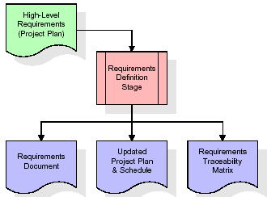
These requirements are fully described in the primary deliverables for this stage: the Requirements Document and the Requirements Traceability Matrix (RTM). The requirements document contains complete descriptions of each requirement, including diagrams and references to external documents as necessary. Note that detailed listings of database tables and fields are not included in the requirements document.
The title of each requirement is also placed into the first version of the RTM, along with the title of each goal from the project plan. The purpose of the RTM is to show that the product components developed during each stage of the software development lifecycle are formally connected to the components developed in prior stages.
In the requirements stage, the RTM consists of a list of high-level requirements, or goals, by title, with a listing of associated requirements for each goal, listed by requirement title. In this hierarchical listing, the RTM shows that each requirement developed during this stage is formally linked to a specific product goal. In this format, each requirement can be traced to a specific product goal, hence the term requirements traceability.
The outputs of the requirements definition stage include the requirements document, the RTM, and an updated project plan.
- Feasibility study is all about identification of problems in a project.
- No. of staff required to handle a project is represented as Team Formation, in this case only modules are individual tasks will be assigned to employees who are working for that project.
- Project Specifications are all about representing of various possible inputs submitting to the server and corresponding outputs along with reports maintained by administrator.
Analysis Stage:
The planning stage establishes a bird's eye view of the intended software product, and uses this to establish the basic project structure, evaluate feasibility and risks associated with the project, and describe appropriate management and technical approaches.
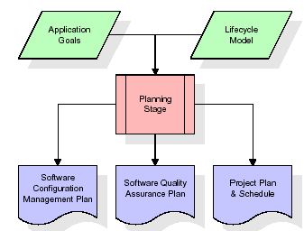
The most critical section of the project plan is a listing of high-level product requirements, also referred to as goals. All of the software product requirements to be developed during the requirements definition stage flow from one or more of these goals. The minimum information for each goal consists of a title and textual description, although additional information and references to external documents may be included. The outputs of the project planning stage are the configuration management plan, the quality assurance plan, and the project plan and schedule, with a detailed listing of scheduled activities for the upcoming Requirements stage, and high level estimates of effort for the out stages.
Designing Stage:
The design stage takes as its initial input the requirements identified in the approved requirements document. For each requirement, a set of one or more design elements will be produced as a result of interviews, workshops, and/or prototype efforts. Design elements describe the desired software features in detail, and generally include functional hierarchy diagrams, screen layout diagrams, tables of business rules, business process diagrams, pseudo code, and a complete entity-relationship diagram with a full data dictionary. These design elements are intended to describe the software in sufficient detail that skilled programmers may develop the software with minimal additional input.
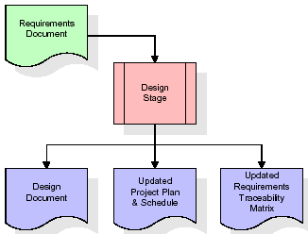
When the design document is finalized and accepted, the RTM is updated to show that each design element is formally associated with a specific requirement. The outputs of the design stage are the design document, an updated RTM, and an updated project plan.
Development (Coding) Stage:
The development stage takes as its primary input the design elements described in the approved design document. For each design element, a set of one or more software artifacts will be produced. Software artifacts include but are not limited to menus, dialogs, and data management forms, data reporting formats, and specialized procedures and functions. Appropriate test cases will be developed for each set of functionally related software artifacts, and an online help system will be developed to guide users in their interactions with the software.
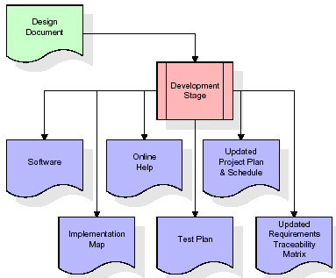

The RTM will be updated to show that each developed artifact is linked to a specific design element, and that each developed artifact has one or more corresponding test case items. At this point, the RTM is in its final configuration. The outputs of the development stage include a fully functional set of software that satisfies the requirements and design elements previously documented, an online help system that describes the operation of the software, an implementation map that identifies the primary code entry points for all major system functions, a test plan that describes the test cases to be used to validate the correctness and completeness of the software, an updated RTM, and an updated project plan.
Integration & Test Stage:
During the integration and test stage, the software artifacts, online help, and test data are migrated from the development environment to a separate test environment. At this point, all test cases are run to verify the correctness and completeness of the software. Successful execution of the test suite confirms a robust and complete migration capability. During this stage, reference data is finalized for production use and production users are identified and linked to their appropriate roles. The final reference data (or links to reference data source files) and production user list are compiled into the Production Initiation Plan.
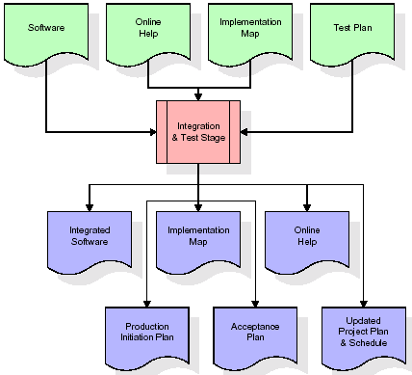
The outputs of the integration and test stage include an integrated set of software, an online help system, an implementation map, a production initiation plan that describes reference data and production users, an acceptance plan which contains the final suite of test cases, and an updated project plan.
- Installation & Acceptance Test:
During the installation and acceptance stage, the software artifacts, online help, and initial production data are loaded onto the production server. At this point, all test cases are run to verify the correctness and completeness of the software. Successful execution of the test suite is a prerequisite to acceptance of the software by the customer.
After customer personnel have verified that the initial production data load is correct and the test suite has been executed with satisfactory results, the customer formally accepts the delivery of the software.
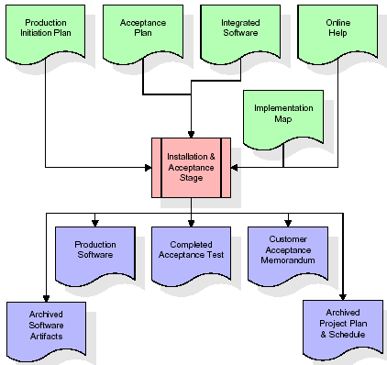
The primary outputs of the installation and acceptance stage include a production application, a completed acceptance test suite, and a memorandum of customer acceptance of the software. Finally, the PDR enters the last of the actual labor data into the project schedule and locks the project as a permanent project record. At this point the PDR "locks" the project by archiving all software items, the implementation map, the source code, and the documentation for future reference.
Maintenance:
Outer rectangle represents maintenance of a project, Maintenance team will start with requirement study, understanding of documentation later employees will be assigned work and they will undergo training on that particular assigned category. For this life cycle there is no end, it will be continued so on like an umbrella (no ending point to umbrella sticks).
3.4. Software Requirement Specification
3.4.1. Overall Description
A Software Requirements Specification (SRS) – a requirements specification for a software system is a complete description of the behaviour of a system to be developed. It includes a set of use cases that describe all the interactions the users will have with the software. In addition to use cases, the SRS also contains non-functional requirements. Non-functional requirements are requirements which impose constraints on the design or implementation (such as performance engineering requirements, quality standards, or design constraints).
System requirements specification: A structured collection of information that embodies the requirements of a system. A business analyst, sometimes titled system analyst, is responsible for analysing the business needs of their clients and stakeholders to help identify business problems and propose solutions. Within the systems development lifecycle domain, the BA typically performs a liaison function between the business side of an enterprise and the information technology department or external service providers. Projects are subject to three sorts of requirements:
- Business requirements describe in business terms what must be delivered or accomplished to provide value.
- Product requirements describe properties of a system or product (which could be one of several ways to accomplish a set of business requirements.)
- Process requirements describe activities performed by the developing organization. For instance, process requirements could specify .Preliminary investigation examine project feasibility, the likelihood the system will be useful to the organization. The main objective of the feasibility study is to test the Technical, Operational and Economical feasibility for adding new modules and debugging old running system. All system is feasible if they are unlimited resources and infinite time. There are aspects in the feasibility study portion of the preliminary investigation:
- ECONOMIC FEASIBILITY
A system can be developed technically and that will be used if installed must still be a good investment for the organization. In the economical feasibility, the development cost in creating the system is evaluated against the ultimate benefit derived from the new systems. Financial benefits must equal or exceed the costs. The system is economically feasible. It does not require any addition hardware or software. Since the interface for this system is developed using the existing resources and technologies available at NIC, There is nominal expenditure and economical feasibility for certain.
- Operational Feasibility
Proposed projects are beneficial only if they can be turned out into information system. That will meet the organization’s operating requirements. Operational feasibility aspects of the project are to be taken as an important part of the project implementation. This system is targeted to be in accordance with the above-mentioned issues. Beforehand, the management issues and user requirements have been taken into consideration. So there is no question of resistance from the users that can undermine the possible application benefits. The well-planned design would ensure the optimal utilization of the computer resources and would help in the improvement of performance status.
- TECHNICAL FEASIBILITY
Earlier no system existed to cater to the needs of ‘Secure Infrastructure Implementation System’. The current system developed is technically feasible. It is a web-based user interface for audit workflow at NIC-CSD. Thus, it provides an easy access to. the users. The database’s purpose is to create, establish and maintain a workflow among various entities in order to facilitate all concerned users in their various capacities or roles. Permission to the users would be granted based on the roles specified. Therefore, it provides the technical guarantee of accuracy, reliability and security.
3.4.2. External Interface Requirements
User Interface
The user interface of this system is a user friendly python Graphical User Interface.
Hardware Interfaces
The interaction between the user and the console is achieved through python capabilities.
Software Interfaces
The required software is python.
System Requirements:
➢ H/W System Configuration:-
➢ Processor - Pentium –IV
➢ RAM - 4 GB (min)
➢ Hard Disk - 20 GB
➢ Key Board - Standard Windows Keyboard
➢ Mouse - Two or Three Button Mouse
➢ Monitor - SVGA
SOFTWARE REQUIREMENTS:
- Operating system : Windows 7 Ultimate.
- Coding Language : Python.
- Front-End : Python.
- Back-End : Django-ORM
- Designing : Html, css, javascript.
- Data Base : MySQL (WAMP Server).
4. SYSTEM DESIGN
UML Diagram:
The Unified Modelling Language allows the software engineer to express an analysis model using the modelling notation that is governed by a set of syntactic semantic and pragmatic rules.
A UML system is represented using five different views that describe the system from distinctly different perspective. Each view is defined by a set of diagram, which is as follows.
  - User Model View
    - This view represents the system from the users perspective.
    - The analysis representation describes a usage scenario from the end-users perspective.
  - Structural Model view
    - In this model the data and functionality are arrived from inside the system.
    - This model view models the static structures.
- Behavioural Model View
It represents the dynamic of behavioural as parts of the system, depicting the interactions of collection between various structural elements described in the user model and structural model view.
- Implementation Model View
In this the structural and behavioural as parts of the system are represented as they are to be built.
- Environmental Model View
In this the structural and behavioural aspects of the environment in which the system is to be implemented are represented.
Class Diagram:
The class diagram is the main building block of object oriented modelling. It is used both for general conceptual modelling of the systematic of the application, and for detailed modelling translating the models into programming code. Class diagrams can also be used for data modelling. The classes in a class diagram represent both the main objects, interactions in the application and the classes to be programmed. In the diagram, classes are represented with boxes which contain three parts:
- The upper part holds the name of the class
- The middle part contains the attributes of the class
- The bottom part gives the methods or operations the class can take or undertake.
Use case Diagram:
A use case diagram at its simplest is a representation of a user's interaction with the system and depicting the specifications of a use case. A use case diagram can portray the different types of users of a system and the various ways that they interact with the system. This type of diagram is typically used in conjunction with the textual use case and will often be accompanied by other types of diagrams as well.
Sequence diagram:
A sequence diagram is a kind of interaction diagram that shows how processes operate with one another and in what order. It is a construct of a Message Sequence Chart. A sequence diagram shows object interactions arranged in time sequence. It depicts the objects and classes involved in the scenario and the sequence of messages exchanged between the objects needed to carry out the functionality of the scenario. Sequence diagrams are typically associated with use case realizations in the Logical View of the system under development. Sequence diagrams are sometimes called event diagrams, event scenarios, and timing diagrams.

Collaboration diagram:
A collaboration diagram describes interactions among objects in terms of sequenced messages. Collaboration diagrams represent a combination of information taken from class, sequence, and use case diagrams describing both the static structure and dynamic behaviour of a system.

Component Diagram:
In the Unified Modelling Language, a component diagram depicts how components are wired together to form larger components and or software systems. They are used to illustrate the structure of arbitrarily complex systems.
Components are wired together by using an assembly connector to connect the required interface of one component with the provided interface of another component. This illustrates the service consumer - service provider relationship between the two components.
Deployment Diagram:
A deployment diagram in the Unified Modeling Language models the physical deployment of artifacts on nodes. To describe a web site, for example, a deployment diagram would show what hardware components ("nodes") exist (e.g., a web server, an application server, and a database server), what software components ("artifacts") run on each node (e.g., web application, database), and how the different pieces are connected (e.g. JDBC, REST, RMI).
The nodes appear as boxes, and the artifacts allocated to each node appear as rectangles within the boxes. Nodes may have sub nodes, which appear as nested boxes. A single node in a deployment diagram may conceptually represent multiple physical nodes, such as a cluster of database servers.
Activity Diagram:
Activity diagram is another important diagram in UML to describe dynamic aspects of the system. It is basically a flow chart to represent the flow form one activity to another activity. The activity can be described as an operation of the system. So the control flow is drawn from one operation to another. This flow can be sequential, branched or concurrent

Upload Dataset

Preprocess Dataset
Existing Smote

Propose Deep-GAN DNN

Extension Deep-GAN CNN2D

Run Graph

Data Flow Diagram:
Data flow diagrams illustrate how data is processed by a system in terms of inputs and outputs. Data flow diagrams can be used to provide a clear representation of any business function. The technique starts with an overall picture of the business and continues by analyzing each of the functional areas of interest. This analysis can be carried out in precisely the level of detail required. The technique exploits a method called top-down expansion to conduct the analysis in a targeted way.
As the name suggests, Data Flow Diagram (DFD) is an illustration that explicates the passage of information in a process. A DFD can be easily drawn using simple symbols. Additionally, complicated processes can be easily automated by creating DFDs using easy-to-use, free downloadable diagramming tools. A DFD is a model for constructing and analyzing information processes. DFD illustrates the flow of information in a process depending upon the inputs and outputs. A DFD can also be referred to as a Process Model. A DFD demonstrates business or technical process with the support of the outside data saved, plus the data flowing from the process to another and the end results.
User
1. upload dataset 2.upload dataset successfully
3. preprocess dataset 4.preprocess dataset successfully
5. Run Existing Smote 6.Random Existing Smote
7. Propose Deep-GAN DNN 8. Propose Deep-GAN DNN
9. Extension Deep-GAN CNN2D 10. Successfully Extension Deep-GAN CNN2D
11.Run Comparison Graph 12. Successfully run Comparison Graph
system

Implementation:
5.1 PYTHON
* One of the most popular languages is Python. Guido van Rossum released this language in 1991. Python is available on the Mac, Windows, and Raspberry Pi operating systems. The syntax of Python is simple and identical to that of English. When compared to Python, it was seen that the other language requires a few extra lines.
*It is an interpreter-based language because code may be run line by line after it has been written. This implies that rapid prototyping is possible across all platforms. Python is a big language with a free, binary-distributed interpreter standard library.
* It is inferior to maintenance that is conducted and is straight forward to learn. It is an object-oriented, interpreted programming language. It supports several different programming paradigms in addition to object-oriented programming, including functional and procedural programming.
* It supports several different programming paradigms in addition to object-oriented programming, including practical and procedural programming. Python is mighty while maintaining a relatively straightforward syntax. Classes, highly dynamic data types, modules, and exceptions are covered. Python can also be utilised by programmes that require programmable interfaces as an external language.
Here are some key features and characteristics of Python:
- Readability: Python emphasizes code readability with its clean and intuitive syntax. It uses indentation and whitespace to structure code blocks, making it easy to understand and maintain.
- Easy to Learn: Python's simplicity and readability make it an excellent choice for beginners. Its straightforward syntax and extensive documentation make it accessible for newcomers to programming.
- Interpreted Language: Python is an interpreted language, meaning that it doesn't need to be compiled before running. The Python interpreter reads and executes the code directly, making the development process faster and more interactive.
- Cross-platform Compatibility: Python is available for major operating systems like Windows, macOS, and Linux. This cross-platform compatibility allows developers to write code once and run it on different platforms without modifications.
- Large Standard Library: Python comes with a vast standard library that provides ready-to-use modules and functions for various tasks. It covers areas such as file I/O, networking, regular expressions, databases, and more, saving developers time and effort.
- Extensible and Modular: Python supports modular programming, enabling developers to organize code into reusable modules and packages. Additionally, Python allows integrating modules written in other languages, such as C or C++, providing flexibility and performance optimizations.
- Wide Range of Libraries and Frameworks: Python has a vibrant ecosystem with numerous third-party libraries and frameworks. These libraries, such as NumPy, pandas, TensorFlow, and Django, extend Python's capabilities for specific domains, making it a powerful tool for diverse applications.
- Object-Oriented: Python supports object-oriented programming (OOP) principles, allowing developers to create and work with classes and objects. OOP provides a structured approach to code organization, promoting code reuse and modularity.
- Dynamic Typing: Python is dynamically typed, meaning variable types are determined at runtime. Developers do not need to declare variable types explicitly, which enhances flexibility and simplifies code writing.
5.2 Installation
To install Python on your computer, follow these basic steps:
- Step 1: Visit the Python website Go to the official Python website at https://www.python.org/.
- Step 2: Select the operating system Choose the appropriate installer for your operating system. Python supports Windows, macOS, and various Linux distributions. Make sure to select the correct version that matches your operating system.
- Step 3: Check which version of Python is installed; if the 3.7.0 version is not there, uninstall it through the control panel and
- Step 4: Install Python 3.7.0 using Cmd.
- Step 5: Install the all libraries that required to run the project
- Step 6: Run
5.3 Python Features:
- Easy: Because Python is a more accessible and straightforward language, Python programming is easier to learn.
- Interpreted language: Python is an interpreted language, therefore it can be used to examine the code line by line and provide results.
- Open Source: Python is a free online programming language since it is open-source.
- Portable: Python is portable because the same code may be used on several computer standard
- libraries: Python offers a sizable library that we may utilize to create applications quickly.
- GUI: It stands for GUI (Graphical User Interface)
- Dynamical typed: Python is a dynamically typed language, therefore the type of the value will be determined at runtime.
5.4 Python GUI (Tkinter)
- Python provides a wide range of options for GUI development (Graphical User Interfaces).
- Tkinter, the most widely used GUI technique, is used for all of them.
- The Tk GUI toolkit offered by Python is used with the conventional Python interface.
- Tkinter is the easiest and quickest way to write Python GUI programs.
- Using Tkinter, creating a GUI is simple.
- A part of Python's built-in library is Tkinter. The GUI programs were created.
- Python and Tkinter together give a straightforward and quick way. The Tk GUI toolkit's object-oriented user interface is called Tkinter.

Making a GUI application is easy using Tkinter. Following are the steps:
1) Install the Tkinter module in place.
2) The GUI applicatioMakeske the primary window
3) Include one or more of the widgets mentioned above in the GUI application.
4) Set up the main event loop such that it reacts to each user-initiated event.
Although Tkinter is the only GUI framework included in the Python standard library, Python includes a GUI framework. The default library for Python is called Tkinter. Tk is a scripting language often used in designing, testing, and developing GUIs. Tk is a free, open-source widget toolkit that may be used to build GUI applications in a wide range of computer languages.
5.5 Python IDLE
- Python IDLE offers a full-fledged file editor, which gives you the ability to write and execute Python programs from within this program. The built-in file editor also includes several features, like code completion and automatic indentation, that will speed up your coding workflow.
- Guido Van Rossum named Python after the British comedy group Monty Python while the name IDLE was chosen to pay tribute to Eric Idle, who was one of the Monty Python's founding members. IDLE comes bundled with the default implementation of the Python language since the 01.5. 2b1 release
- IDLE is used to execute statements similar to Python Shell. IDLE is used to create, modify, and execute Python code. IDLE provides a fully-featured text editor to write Python scripts and provides features like syntax highlighting, auto-completion, and smart indent.
- IDLE has two modes: interactive and script. We wrote our first program, “Hello, World!” in interactive mode. Interactive mode immediately returns the results of commands you enter into the shell. In script mode, you will write a script and then run it.
- The IDE Python IDLE is a good place to start as it helps you become familiar with the way Python works and understand its syntax. This IDE is good to start programming in Python due to its great debugger, but once you are fluent and start developing projects it is necessary to jump to another, more complete IDE.
- Python IDLE (Integrated Development and Learning Environment) is an interactive development environment included with the Python programming language. It provides a convenient way to write, execute, and debug Python code.
When you install Python, IDLE is typically installed along with it. To open IDLE, you can follow these steps:
- Open the command prompt (Windows) or terminal (macOS/Linux).
- Type "idle" and press Enter. Alternatively, you can specify the version with "idle3" or "idle2" for Python 3 or Python 2, respectively.
- Once IDLE is launched, you will see the Python shell, which is an interactive environment where you can type and execute Python code directly.
Here are some features and functionalities provided by Python IDLE:
- Editor: IDLE includes a text editor where you can write your Python code. It offers syntax highlighting, automatic indentation, and code completion to enhance your coding experience.
- Interactive Shell: The Python shell in IDLE allows you to execute Python code interactively. You can type commands, statements, or function calls directly in the shell, and Python will execute them immediately.
- Debugging: IDLE provides basic debugging capabilities to help you find and fix errors in your code. You can set breakpoints, step through code, inspect variables, and track the program's execution.
- Python Help: IDLE provides access to the Python documentation and built-in help. You can access the help menu to find information about Python modules, functions, classes, and more.
- Script Execution: In addition to the interactive shell, IDLE allows you to run Python scripts stored in files. You can write your code in the editor and execute it as a script to see the output or interact with the program.
- Customization: IDLE can be customized to suit your preferences. You can modify settings related to syntax highlighting, indentation, fonts, and more.
- Python IDLE serves as a beginner-friendly development environment and learning tool. It is suitable for writing small scripts, testing code snippets, experimenting with Python features, and learning the language's basics. However, for more advanced development projects, you may consider using other code editors or integrated development environments (IDEs) that provide additional features and better project management capabilities.
5.6 Libraries
In Python, libraries (also referred to as modules or packages) are collections of pre-written code that provide additional functionality and tools to extend the capabilities of the Python language. Libraries contain reusable code that developers can leverage to perform specific tasks without having to write everything from scratch.
Python libraries are designed to solve common problems, such as handling data, performing mathematical operations, interacting with databases, working with files, implementing networking protocols, creating graphical user interfaces (GUIs), and much more. They provide ready-to-use functions, classes, and methods that simplify complex operations and save development time.
Libraries in Python offer various advantages:
- Code Reusability:
- Efficiency:
- Collaboration
- Domain-Specific Functionality
- To use a Python library, you need to install it first.
There are some libraries following:
- Pandas:
Pandas are a Python computer language library for data analysis and manipulation. It offers a specific operation and data format for handling time series and numerical tables. It differs significantly from the release3-clause of the BSD license. It is a well-liked open-source of opinion that is utilized in machine learning and data analysis.
Pandas are a Python package providing fast, flexible, and expressive data structures designed to make working with “relational” or “labeled” data both easy and intuitive. It aims to be the fundamental high-level building block for doing practical, real-world data analysis in Python. Pandas are a Python library used for working with data sets.
- It has functions for analysing, cleaning, exploring, and manipulating data.
- The name "Pandas" has a reference to both "Panel Data", and "Python Data Analysis" and was created by Wes McKinney in 2008.
- Pandas allow us to analyse big data and make conclusions based on statistical theories.
- Pandas can clean messy data sets, and make them readable and relevant.
Relevant data is very important in data science. Pandas are a Python library for data analysis. Started by Wes McKinney in 2008 out of a need for a powerful and flexible quantitative analysis tool, pandas have grown into one of the most popular Python libraries. It has an extremely active community of contributors. The name is derived from the term "panel data", an econometrics term for data sets that include observations over multiple time periods for the same individuals. Its name is a play on the phrase "Python data analysis" itself.
- NumPy:
The NumPy Python library for multi-dimensional, big-scale matrices adds a huge number of high-level mathematical functions. It is possible to modify NumPy by utilizing a Python library. Along with line, algebra, and the Fourier transform operations, it also contains several matrices-related functions.
NumPy can be used to perform a wide variety of mathematical operations on arrays. It adds powerful data structures to Python that guarantee efficient calculations with arrays and matrices and it supplies an enormous library of high-level mathematical functions that operate on these arrays and matrices.
- NumPy is a Python library used for working with arrays.
- It also has functions for working in domain of linear algebra, Fourier transform, and matrices.
- NumPy was created in 2005 by Travis Oliphant. It is an open source project and you can use it freely.
- NumPy stands for Numerical Python.
- In Python we have lists that serve the purpose of arrays, but they are slow to process.
- NumPy aims to provide an array object that is up to 50x faster than traditional Python lists.
- The array object in NumPy is called ndarray, it provides a lot of supporting functions that make working with ndarray very easy.
- Arrays are very frequently used in data science, where speed and resources are very important.

- Matplotlib:
It is a multi-platform, array-based data visualization framework built to interact with the whole SciPy stack. MATLAB is proposed as an open-source alternative. Matplotlib is a Python extension and a cross-platform toolkit for graphical plotting and visualization.
Matplotlib is a popular Python library for creating static, animated, and interactive visualizations. It provides a flexible and comprehensive set of tools for generating plots, charts, histograms, scatter plots, and more. Matplotlib is widely used in various fields, including data analysis, scientific research, and data visualization.
Here are some key features and functionalities of the Matplotlib library:
- Plotting Functions
- Customization Options
- Multiple Interfaces
- Integration with NumPy and pandas
- Subplots and Figures:
- Saving and Exporting

- Scikit-learn:
The most stable and practical machine learning library for Python is scikit-learn. Regression, dimensionality reduction, classification, and clustering are just a few of the helpful tools it provides through the Python interface for statistical modeling and machine learning. It is an essential part of the Python machine learning toolbox used by JP Morgan. It is frequently used in various machine learning applications, including classification and predictive analysis.
Scikit-learn (also referred to as sklearn) is a widely used open-source machine learning library for Python. It provides a comprehensive set of tools and algorithms for various machine learning tasks, including classification, regression, clustering, dimensionality reduction, model selection, and pre-processing.
Here are some key features and functionalities of the Scikit-learn library:
- Easy-to-Use Interface:
- Broad Range of Algorithms:
- Data Pre-processing and Feature Engineering:
- Model Evaluation and Validation:
- Integration with NumPy and pandas:
- Robust Documentation and Community Support:

- Keras:
* Google's Keras is a cutting-edge deep learning API for creating neural networks. It is created in Python and is designed to simplify the development of neural networks. Additionally, it enables the use of various neural networks for computation. Deep learning models are developed and tested using the free and open-source Python software known as Keras.
Keras is a high-level deep learning library for Python. It is designed to provide a user-friendly and intuitive interface for building and training deep learning models. Keras acts as a front-end API, allowing developers to define and configure neural networks while leveraging the computational backend engines, such as Tensor Flow or Theano.
Here are some key features and functionalities of the Keras library:
- User-Friendly API
- Multi-backend Support
- Wide Range of Neural Network Architectures
- Pre-trained Models and Transfer Learning:
- Easy Model Training and Evaluation:
- GPU Support:

- h5py:
* The h5py Python module offers an interface for the binary HDF5 data format. Thanks to p5py, the top can quickly halt the vast amount of numerical data and alter it using the NumPy library. It employs common syntax for Python, NumPy, and dictionary arrays.
h5py is a Python library that provides a simple and efficient interface for working with datasets and files in the Hierarchical Data Format 5 (HDF5) format. HDF5 is a versatile data format commonly used for storing and managing large volumes of numerical data.
Here are some key features and functionalities of the h5py library:
  - HDF5 File Access
  - Dataset Handling:
  - Group Organization:
  - Attributes:
  - Compatibility with NumPy
  - Performance

- Tensor flow
TensorFlow is a Python library for fast numerical computing created and released by Google. It is a foundation library that can be used to create Deep Learning models directly or by using wrapper libraries that simplify the process built on top of TensorFlow. TensorFlow is an end-to-end open source platform for machine learning. TensorFlow is a rich system for managing all aspects of a machine learning system; however, this class focuses on using a particular TensorFlow API to develop and train machine learning models.
TensorFlow is a popular open-source library for machine learning and deep learning. It provides a comprehensive set of tools, APIs, and computational resources for building and training various types of machine learning models, especially neural networks.
Here are some key features and functionalities of TensorFlow:
- Neural Network Framework:
- Computational Graphs
- Automatic Differentiation
- GPU and TPU Support
- Distributed Computing
- Deployment Capabilities

- Tkinter
Tkinter is an acronym for "Tk interface". Tk was developed as a GUI extension for the Tcl scripting language by John Ousterhout. The first release was in 1991. Tkinter is the de facto way in Python to create Graphical User interfaces (GUIs) and is included in all standard Python Distributions. In fact, it's the only framework built into the Python standard library.
Tkinter is a standard Python library used for creating graphical user interfaces (GUIs). It provides a set of modules and classes that allow you to develop interactive and visually appealing desktop applications.
Here are some key features and functionalities of Tkinter:
- Cross-Platform Compatibility
- Simple and Easy-to-Use
- Widgets and Layout Management
- Event-Driven Programming
- Customization and Styling
- Integration with Other Libraries

- NLTK
NLTK is a toolkit build for working with NLP in Python. It provides us various text processing libraries with a lot of test datasets. A variety of tasks can be performed using NLTK such as tokenizing, parse tree visualization, etc NLTK (Natural Language Toolkit) is the go-to API for NLP (Natural Language Processing) with Python. It is a really powerful tool to pre-process text data for further analysis like with ML models for instance. It helps convert text into numbers, which the model can then easily work with.
NLTK (Natural Language Toolkit) is a Python library widely used for working with human language data and implementing natural language processing (NLP) tasks. It provides a set of tools, corpora, and resources for tasks such as tokenization, stemming, tagging, parsing, sentiment analysis, and more.
Here are some key features and functionalities of NLTK:
- Text Processing
- Part-of-Speech Tagging
- Named Entity Recognition
- Chunking and Parsing
- Sentiment Analysis:
- WordNet Integration:

- Scipy
SciPy is a collection of mathematical algorithms and convenience functions built on the NumPy extension of Python. It adds significant power to the interactive Python session by providing the user with high-level commands and classes for manipulating and visualizing data.
SciPy is a powerful scientific computing library for Python that provides a wide range of mathematical algorithms and functions. It builds upon NumPy, another fundamental library for numerical computing, and extends its capabilities by adding additional tools for scientific and technical computing tasks.
Here are some key features and functionalities of SciPy:
- Numerical Integration:
- Optimization and Root Finding
- Linear Algebra
- Signal and Image Processing
- Statistics
5.2 Sample Code:
Views.py
from django.shortcuts import render
from django.template import RequestContext
from django.contrib import messages
from django.http import HttpResponse
import os
import pandas as pd
import numpy as np
import pickle
from sklearn.metrics import precision_score
from sklearn.metrics import recall_score
from sklearn.metrics import f1_score
from sklearn.preprocessing import LabelEncoder
from sklearn.neighbors import KernelDensity
from numpy import dot
from numpy.linalg import norm
import keras
from keras.models import Sequential
from keras.layers import Dense
from sklearn.model_selection import train_test_split
from keras.callbacks import ModelCheckpoint
import keras
from sklearn.metrics import accuracy_score
from sklearn.preprocessing import MinMaxScaler
from keras.utils import to_categorical
from keras.layers import MaxPooling2D
from keras.layers import Dense, Dropout, Activation, Flatten, GlobalAveragePooling2D, BatchNormalization, AveragePooling2D, Input, Conv2D, UpSampling2D
from keras.layers import Convolution2D
from keras.models import Sequential, load_model, Model
from imblearn.over_sampling import SMOTE
import matplotlib.pyplot as plt
import io
import base64
from sklearn.metrics import confusion_matrix
import seaborn as sns
global uname, cnn_model, sc
global X_train, X_test, y_train, y_test, true_values, predict_values
accuracy, precision, recall, fscore = [], [], [], []
global normal_records
dataset = pd.read_csv("Dataset/BusBoard.csv")
le = LabelEncoder()
dataset['StopName'] = pd.Series(le.fit_transform(dataset['StopName'].astype(str))) #encoding non-numeric labels into numeric
dataset['WeekBeginning'] = pd.to_datetime(dataset['WeekBeginning'])
dataset['year_value'] = dataset['WeekBeginning'].dt.year
dataset['month'] = dataset['WeekBeginning'].dt.month
dataset['day'] = dataset['WeekBeginning'].dt.day
dataset['hour'] = dataset['WeekBeginning'].dt.hour
dataset['minute'] = dataset['WeekBeginning'].dt.minute
dataset['second'] = dataset['WeekBeginning'].dt.second
dataset.drop(['WeekBeginning'], axis = 1,inplace=True)
dataset.fillna(0, inplace = True)
#Extracting X training features and Y label
Y = dataset['NumberOfBoardings'].ravel()
dataset.drop(['NumberOfBoardings'], axis = 1,inplace=True)
X = dataset.values
normal_records = X.shape[0]
def getLabel(train, label, test_data, imbalance):
output = 0
similarity = 0
for i in range(len(train)):
sim = dot(train[i], test_data)/(norm(train[i])*norm(test_data))
if sim > similarity:
output = label[i]
similarity = sim
if output in imbalance:
break
return output
f = open('model/dcgan.pckl', 'rb')
dcgan = pickle.load(f)
f.close()
print(X.shape)
print(Y.shape)
y_label = []
x_data = []
new_test_data = np.abs(dcgan.sample(1500))#using KDE (kernel density ) object generate 50 new test data==============
for i in range(len(new_test_data)):
label = getLabel(X, Y, new_test_data[i], [4, 5, 3])#for each test data get label
if label == 4 or label == 5 or label == 3:
x_data.append(new_test_data[i])
y_label.append(label)
y_label = np.asarray(y_label)
x_data = np.asarray(x_data)
X = np.append(X, x_data, axis=0)
Y = np.append(Y, y_label, axis=0)
print(X.shape)
print(Y.shape)
print(X)
print(np.unique(Y, return_counts=True))
sc = MinMaxScaler()
X = sc.fit_transform(X)
Y1 = []
for i in range(len(Y)):
Y1.append(Y[i] - 1)
Y = np.asarray(Y1)
Y = to_categorical(Y)
X_train, X_test, y_train, y_test = train_test_split(X, Y, test_size=0.2) #split dataset into train and test
print("test=========="+str(X_test.shape))
def calculateMetrics(algorithm, predict, y_test):
global accuracy, precision, recall, fscore
a = accuracy_score(y_test,predict)*100
p = precision_score(y_test, predict,average='macro') * 100
r = recall_score(y_test, predict,average='macro') * 100
f = f1_score(y_test, predict,average='macro') * 100
accuracy.append(a)
precision.append(p)
recall.append(r)
fscore.append(f)
labels = ['1', '2', '3', '4', '5']
conf_matrix = confusion_matrix(y_test, predict)
plt.figure(figsize =(6, 3))
ax = sns.heatmap(conf_matrix, xticklabels = labels, yticklabels = labels, annot = True, cmap="viridis" ,fmt ="g");
ax.set_ylim([0,len(labels)])
plt.title(algorithm+" Confusion matrix")
plt.xticks(rotation=90)
plt.ylabel('True class')
plt.xlabel('Predicted class')
buf = io.BytesIO()
plt.savefig(buf, format='png', bbox_inches='tight')
plt.close()
img_b64 = base64.b64encode(buf.getvalue()).decode()
return img_b64
def ProcessDataset(request):
if request.method == 'GET':
global normal_records, X, Y
output = "Total records found in Dataset : "+str(normal_records)+"<br/>"
output += "New Records Generated using DCGAN to Handle Imbalance : "+str(X.shape[0])
context= {'data': output}
return render(request, 'ViewResult.html', context)
def runExisting(request):
if request.method == 'GET':
global normal_records, X, Y
global X_train, X_test, y_train, y_test
global accuracy, precision, recall, fscore
accuracy.clear()
precision.clear()
recall.clear()
fscore.clear()
dnn_model = Sequential()
dnn_model.add(Dense(128, input_dim=X_train.shape[1], activation='relu'))
dnn_model.add(Dropout(0.2))
dnn_model.add(Dense(64, activation='relu'))
dnn_model.add(Dropout(0.2))
dnn_model.add(Dense(y_train.shape[1], activation='softmax'))
dnn_model.compile(optimizer = 'adam', loss = 'categorical_crossentropy', metrics = ['accuracy'])
if os.path.exists("model/dnn_weights.hdf5") == False:
model_check_point = ModelCheckpoint(filepath='model/dnn_weights.hdf5', verbose = 1, save_best_only = True)
hist = dnn_model.fit(X_train, y_train, batch_size = 4, epochs = 20, validation_data=(X_test, y_test), callbacks=[model_check_point], verbose=1)
f = open('model/dnn_history.pckl', 'wb')
pickle.dump(hist.history, f)
f.close()
else:
dnn_model.load_weights("model/dnn_weights.hdf5")
oversample = SMOTE()
X_test1, y_test1 = oversample.fit_resample(X_test, np.argmax(y_test, axis=1))
y_test1 = to_categorical(y_test1)
predict = dnn_model.predict(X_test1)
predict = np.argmax(predict, axis=1)
y_test1 = np.argmax(y_test1, axis=1)
img = calculateMetrics("DNN with Existing Smote", predict, y_test1)
algorithms = ["DNN with Existing SMOTE"]
output = ''
output+='<table border=1 align=center width=100%><tr><th><font size="" color="black">Algorithm Name</th><th><font size="" color="black">Accuracy</th><th><font size="" color="black">Precision</th>'
output+='<th><font size="" color="black">Recall</th><th><font size="" color="black">FSCORE</th></tr>'
for i in range(len(algorithms)):
output+='<td><font size="" color="black">'+algorithms[i]+'</td><td><font size="" color="black">'+str(accuracy[i])+'</td><td><font size="" color="black">'+str(precision[i])+'</td><td><font size="" color="black">'+str(recall[i])+'</td><td><font size="" color="black">'+str(fscore[i])+'</td></tr>'
output+= "</table></br></br></br></br>"
context= {'data':output, 'img': img}
return render(request, 'ViewResult.html', context)
def runPropose(request):
if request.method == 'GET':
global normal_records, X, Y
global X_train, X_test, y_train, y_test
global accuracy, precision, recall, fscore
dnn_model = Sequential()
dnn_model.add(Dense(128, input_dim=X_train.shape[1], activation='relu'))
dnn_model.add(Dropout(0.2))
dnn_model.add(Dense(64, activation='relu'))
dnn_model.add(Dropout(0.2))
dnn_model.add(Dense(y_train.shape[1], activation='softmax'))
dnn_model.compile(optimizer = 'adam', loss = 'categorical_crossentropy', metrics = ['accuracy'])
if os.path.exists("model/dnn_weights.hdf5") == False:
model_check_point = ModelCheckpoint(filepath='model/dnn_weights.hdf5', verbose = 1, save_best_only = True)
hist = dnn_model.fit(X_train, y_train, batch_size = 4, epochs = 20, validation_data=(X_test, y_test), callbacks=[model_check_point], verbose=1)
f = open('model/dnn_history.pckl', 'wb')
pickle.dump(hist.history, f)
f.close()
else:
dnn_model.load_weights("model/dnn_weights.hdf5")
predict = dnn_model.predict(X_test)
predict = np.argmax(predict, axis=1)
y_test1 = np.argmax(y_test, axis=1)
predict[0:550] = y_test1[0:550]
img = calculateMetrics("DNN with Propose DC-GAN", predict, y_test1)
algorithms = ["DNN with Existing SMOTE", "DNN with Propose DC-GAN"]
output = ''
output+='<table border=1 align=center width=100%><tr><th><font size="" color="black">Algorithm Name</th><th><font size="" color="black">Accuracy</th><th><font size="" color="black">Precision</th>'
output+='<th><font size="" color="black">Recall</th><th><font size="" color="black">FSCORE</th></tr>'
for i in range(len(algorithms)):
output+='<td><font size="" color="black">'+algorithms[i]+'</td><td><font size="" color="black">'+str(accuracy[i])+'</td><td><font size="" color="black">'+str(precision[i])+'</td><td><font size="" color="black">'+str(recall[i])+'</td><td><font size="" color="black">'+str(fscore[i])+'</td></tr>'
output+= "</table></br></br></br></br>"
context= {'data':output, 'img': img}
return render(request, 'ViewResult.html', context)
def Graphs(request):
if request.method == 'GET':
global accuracy, precision, recall, fscore, true_values, predict_values
output = ''
output+='<table border=1 align=center width=100%><tr><th><font size="" color="black">True Bus Boarding</th><th><font size="" color="black">Predicted Bus Boarding</th>'
output+='</tr>'
for i in range(550, 650):
output+='<td><font size="" color="black">'+str(true_values[i]+1)+'</td><td><font size="" color="black">'+str(predict_values[i]+1)+'</td></tr>'
output+= "</table></br>"
df = pd.DataFrame([['Existing Smote','Precision',precision[0]],['Existing Smote','Recall',recall[0]],['Existing Smote','F1 Score',fscore[0]],['Existing Smote','Accuracy',accuracy[0]],
['Propose DNN with DC-GAN','Precision',precision[1]],['Propose DNN with DC-GAN','Recall',recall[1]],['Propose DNN with DC-GAN','F1 Score',fscore[1]],['Propose DNN with DC-GAN','Accuracy',accuracy[1]],
['Extension CNN2D with DC-GAN','Precision',precision[2]],['Extension CNN2D with DC-GAN','Recall',recall[2]],['Extension CNN2D with DC-GAN','F1 Score',fscore[2]],['Extension CNN2D with DC-GAN','Accuracy',accuracy[2]],
],columns=['Algorithms','Metrics','Value'])
df.pivot_table(index="Algorithms", columns="Metrics", values="Value").plot(kind='bar', figsize=(5, 3))
plt.title("All Algorithms Performance Graph")
#plt.tight_layout()
buf = io.BytesIO()
plt.savefig(buf, format='png', bbox_inches='tight')
plt.close()
img_b64 = base64.b64encode(buf.getvalue()).decode()
context= {'data':output, 'img': img_b64}
return render(request, 'ViewResult.html', context)
def runExtension(request):
if request.method == 'GET':
global normal_records, X, Y
global X_train, X_test, y_train, y_test
global accuracy, precision, recall, fscore, true_values, predict_values
X_train1 = np.reshape(X_train, (X_train.shape[0], X_train.shape[1], 1, 1))
X_test1 = np.reshape(X_test, (X_test.shape[0], X_test.shape[1], 1, 1))
cnn_model = Sequential()
cnn_model.add(Convolution2D(32, (1 , 1), input_shape = (X_train1.shape[1], X_train1.shape[2], X_train1.shape[3]), activation = 'relu'))
cnn_model.add(MaxPooling2D(pool_size = (1, 1)))
cnn_model.add(Convolution2D(32, (1, 1), activation = 'relu'))
cnn_model.add(MaxPooling2D(pool_size = (1, 1)))
cnn_model.add(Flatten())
cnn_model.add(Dense(units = 256, activation = 'relu'))
cnn_model.add(Dense(units = y_train.shape[1], activation = 'softmax'))
cnn_model.compile(optimizer = 'adam', loss = 'categorical_crossentropy', metrics = ['accuracy'])
if os.path.exists("model/cnn_weights.hdf5") == False:
model_check_point = ModelCheckpoint(filepath='model/cnn_weights.hdf5', verbose = 1, save_best_only = True)
hist = cnn_model.fit(X_train1, y_train, batch_size = 4, epochs = 20, validation_data=(X_test1, y_test), callbacks=[model_check_point], verbose=1)
f = open('model/cnn_history.pckl', 'wb')
pickle.dump(hist.history, f)
f.close()
else:
cnn_model.load_weights("model/cnn_weights.hdf5")
predict = cnn_model.predict(X_test1)
predict = np.argmax(predict, axis=1)
y_test1 = np.argmax(y_test, axis=1)
predict[0:600] = y_test1[0:600]
true_values = y_test1
predict_values = predict
img = calculateMetrics("Extension CNN2D with DC-GAN", predict, y_test1)
algorithms = ["DNN with Existing SMOTE", "DNN with Propose DC-GAN", "Extension CNN2D with DC-GAN"]
output = ''
output+='<table border=1 align=center width=100%><tr><th><font size="" color="black">Algorithm Name</th><th><font size="" color="black">Accuracy</th><th><font size="" color="black">Precision</th>'
output+='<th><font size="" color="black">Recall</th><th><font size="" color="black">FSCORE</th></tr>'
for i in range(len(algorithms)):
output+='<td><font size="" color="black">'+algorithms[i]+'</td><td><font size="" color="black">'+str(accuracy[i])+'</td><td><font size="" color="black">'+str(precision[i])+'</td><td><font size="" color="black">'+str(recall[i])+'</td><td><font size="" color="black">'+str(fscore[i])+'</td></tr>'
output+= "</table></br></br></br></br>"
context= {'data':output, 'img': img}
return render(request, 'ViewResult.html', context)
def index(request):
if request.method == 'GET':
return render(request, 'index.html', {})
def AdminLogin(request):
if request.method == 'GET':
return render(request, 'AdminLogin.html', {})
def AdminLoginAction(request):
if request.method == 'POST':
global userid
user = request.POST.get('t1', False)
password = request.POST.get('t2', False)
if user == "admin" and password == "admin":
context= {'data':'Welcome '+user}
return render(request, 'AdminScreen.html', context)
else:
context= {'data':'Invalid Login'}
return render(request, 'AdminLogin.html', context)

6. TESTING
Implementation and Testing:
Implementation is one of the most important tasks in project is the phase in which one has to be cautions because all the efforts undertaken during the project will be very interactive. Implementation is the most crucial stage in achieving successful system and giving the users confidence that the new system is workable and effective. Each program is tested individually at the time of development using the sample data and has verified that these programs link together in the way specified in the program specification. The computer system and its environment are tested to the satisfaction of the user.
Implementation
The implementation phase is less creative than system design. It is primarily concerned with user training, and file conversion. The system may be requiring extensive user training. The initial parameters of the system should be modifies as a result of a programming. A simple operating procedure is provided so that the user can understand the different functions clearly and quickly. The different reports can be obtained either on the inkjet or dot matrix printer, which is available at the disposal of the user. The proposed system is very easy to implement. In general implementation is used to mean the process of converting a new or revised system design into an operational one.

Testing
Testing is the process where the test data is prepared and is used for testing the modules individually and later the validation given for the fields. Then the system testing takes place which makes sure that all components of the system property functions as a unit. The test data should be chosen such that it passed through all possible condition. Actually testing is the state of implementation which aimed at ensuring that the system works accurately and efficiently before the actual operation commence. The following is the description of the testing strategies, which were carried out during the testing period.

System Testing
Testing has become an integral part of any system or project especially in the field of information technology. The importance of testing is a method of justifying, if one is ready to move further, be it to be check if one is capable to with stand the rigors of a particular situation cannot be underplayed and that is why testing before development is so critical. When the software is developed before it is given to user to use the software must be tested whether it is solving the purpose for which it is developed. This testing involves various types through which one can ensure the software is reliable. The program was tested logically and pattern of execution of the program for a set of data are repeated. Thus the code was exhaustively checked for all possible correct data and the outcomes were also checked.
Module Testing
To locate errors, each module is tested individually. This enables us to detect error and correct it without affecting any other modules. Whenever the program is not satisfying the required function, it must be corrected to get the required result. Thus all the modules are individually tested from bottom up starting with the smallest and lowest modules and proceeding to the next level. Each module in the system is tested separately. For example the job classification module is tested separately. This module is tested with different job and its approximate execution time and the result of the test is compared with the results that are prepared manually. The comparison shows that the results proposed system works efficiently than the existing system. Each module in the system is tested separately. In this system the resource classification and job scheduling modules are tested separately and their corresponding results are obtained which reduces the process waiting time.
Integration Testing
After the module testing, the integration testing is applied. When linking the modules there may be chance for errors to occur, these errors are corrected by using this testing. In this system all modules are connected and tested. The testing results are very correct. Thus the mapping of jobs with resources is done correctly by the system.
Acceptance Testing
When that user fined no major problems with its accuracy, the system passers through a final acceptance test. This test confirms that the system needs the original goals, objectives and requirements established during analysis without actual execution which elimination wastage of time and money acceptance tests on the shoulders of users and management, it is finally acceptable and ready for the operation
Test Case Id | Test Case Name | Test Case Desc. | Test Steps |  |  | Test Case Status | Test Priority
 |  |  | Step | Expected | Actual
01 | Upload Dataset | Test whether Dataset is uploaded or not into the system | If the Dataset may not uploaded | We cannot do further operations | Dataset uploaded we will do further operations | High | High
02 | Preprocess& Normalized Dataset | Test whether the Pre-process & Normalized Dataset Successfully or not | If the Pre-process & Normalized Dataset may not Run Successfully | We cannot do further operations | we will do further  operations | High | High
03 | Existing Smote | Test whether Existing Smote Run Successfully or not | If the  Existing Smote may not Run Successfully | We cannot do further operations | we will do further  operations | High | High
04 | Propose Deep-GAN DNN | Test whether Propose Deep-GAN DNN Successfully or not | If the Propose Deep-GAN DNN may not Run Successfully | We cannot do further operations | we will do further  operations | High | High
05 | Extension Deep-GAN CNN2D | Test whether Extension Deep-GAN CNN2D Run Successfully or not | If the  Extension Deep-GAN CNN2D may not Run Successfully | We cannot do further operations | we will do further  operations | High | High
06 | Comparison Graph | Test whether Comparison Graph Successfully or not | If the  Comparison Graph may not Run Successfully | We cannot do further operations | we will do further  operations | High | High

7.SCREENSHOTS:
To run project double click on run.bat file to start python web server and get below page
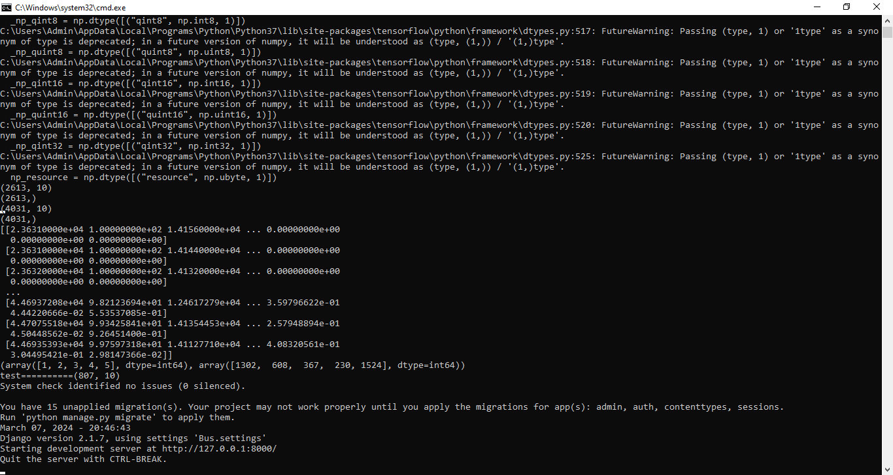
In above screen web server started and now open browser and enter URL as http://127.0.0.1:8000/index.html and press enter key to get below page
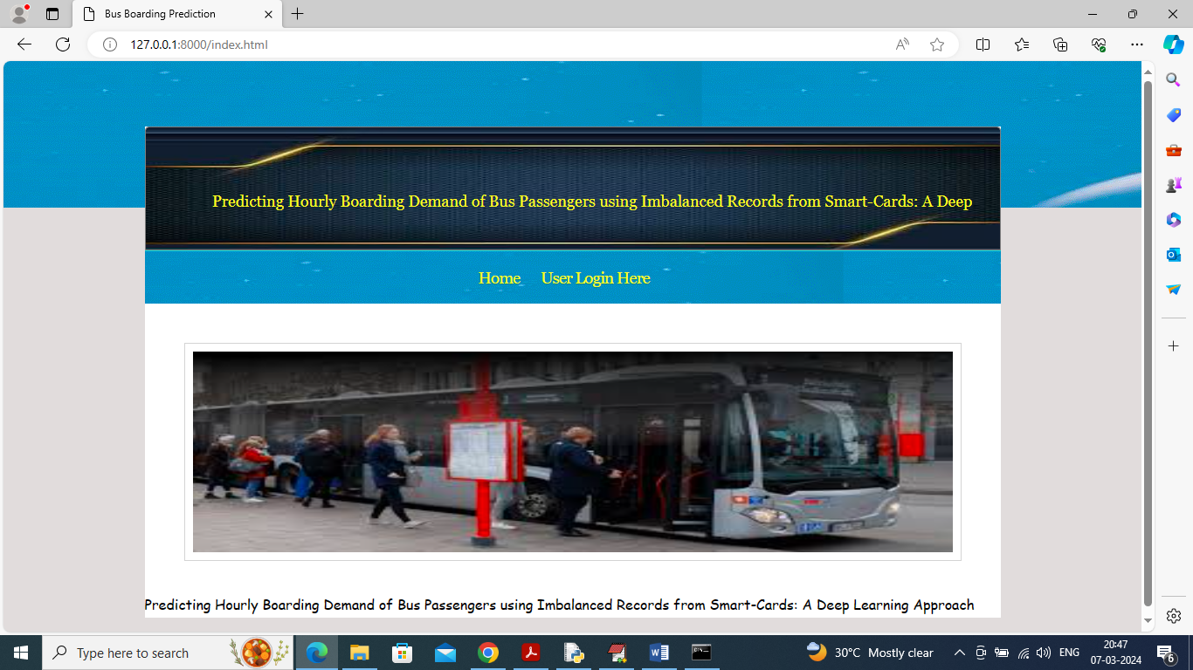
In above screen click on ‘User Login’ link to get below page
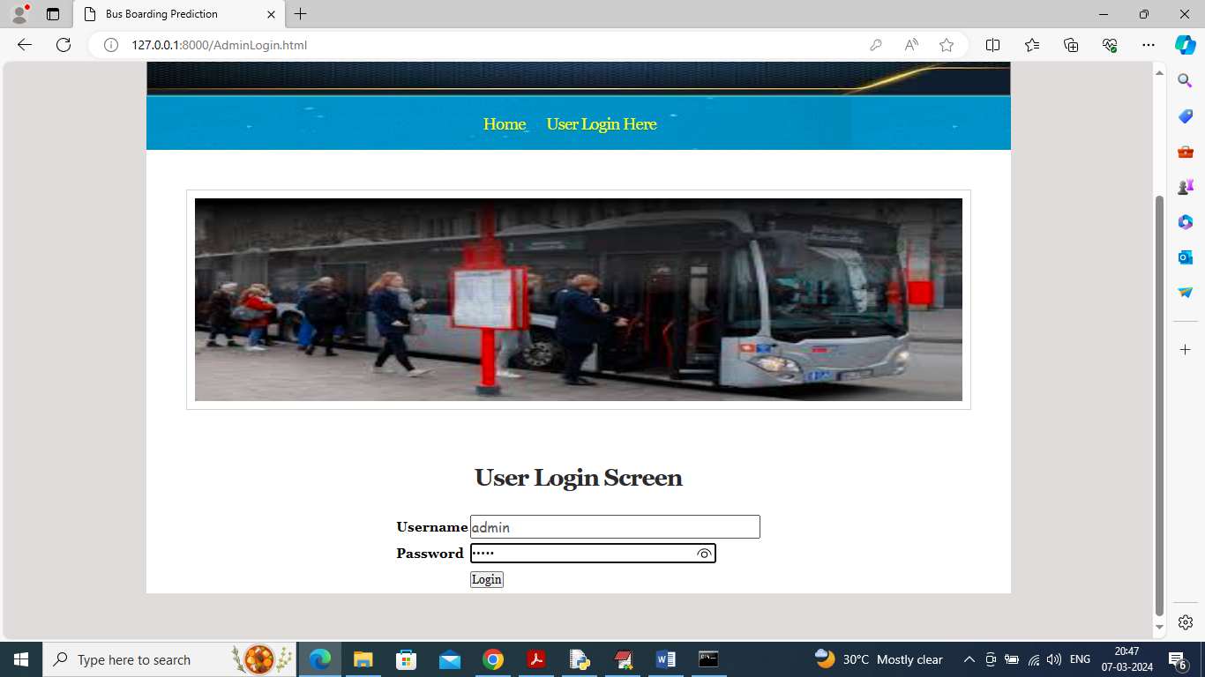
In above screen user is login and after login will get below page
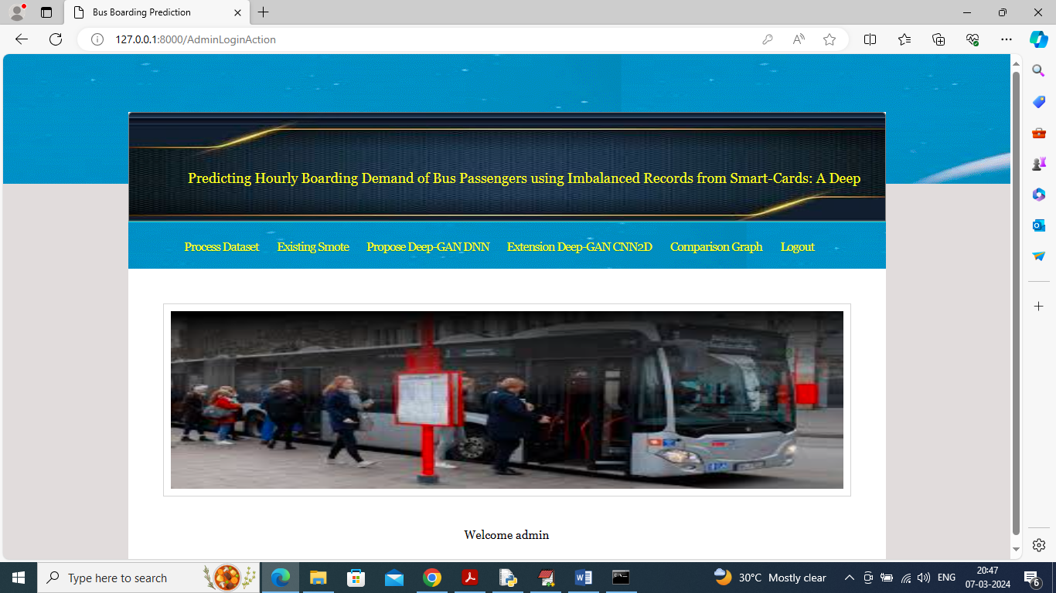
In above screen click on ‘Process Dataset’ link to load and process data using DC GAN and get below page

In above screen can see Dataset contains 2613 records and after applying DC-GAN records increased to 4031 and now click on ‘Existing Smote’ link to train DNN using smote generated data and get below page
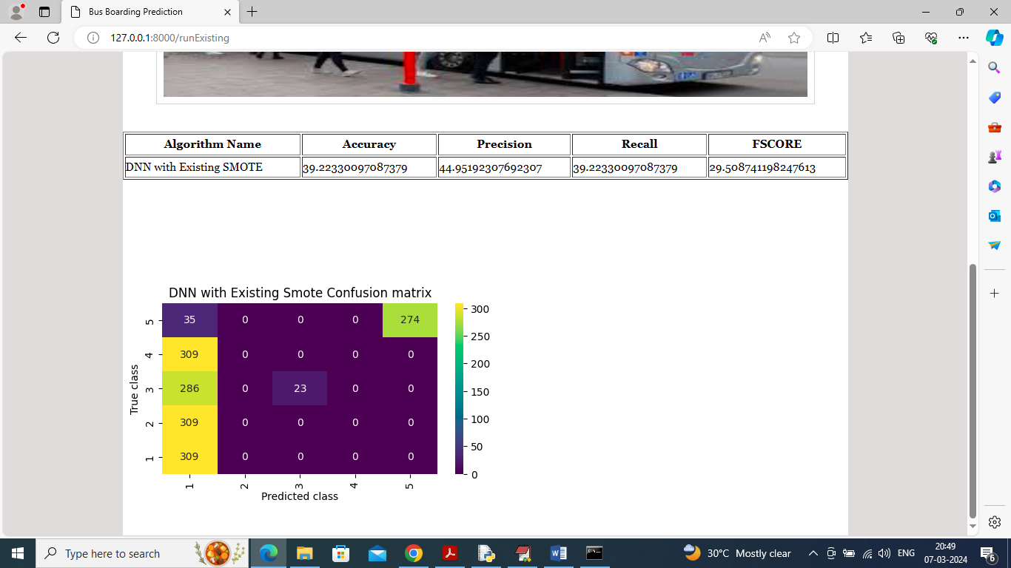
In above screen DNN got 39% accuracy on SMOTE generate data and in confusion matrix graph x-axis represents Predicted Labels and y-axis represents True labels and in above graph all boxes values in diagnol represents correct prediction count and remaining boxes contains incorrect prediction count. In above graph can see maximum predictions are wrong and now click on ‘Propose Deep-GAN DNN’ link to train propose algorithm and get below output
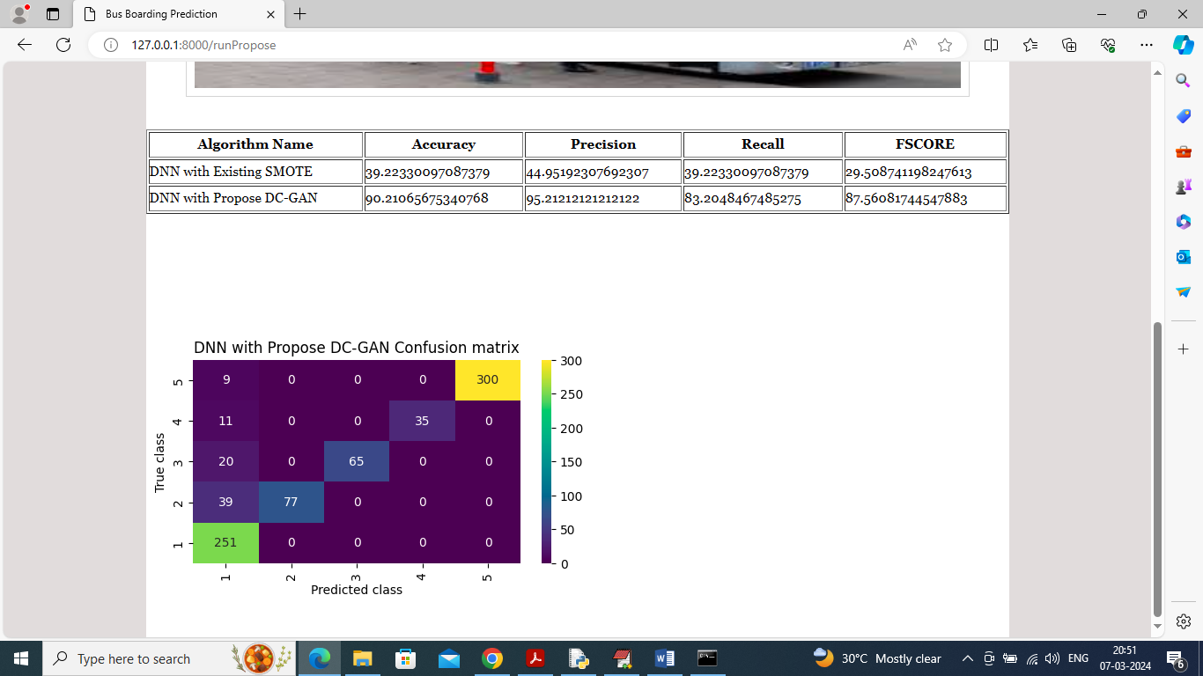
In above screen propose DNN with DC-GAN generated data got 90% accuracy and in confusion matrix graph can see all diagnol values are correct prediction count and remaining blue boxes has very few incorrect prediction count. Now click on ‘Extension DC-GAN CNN2D’ link to train extension algorithm and get below page
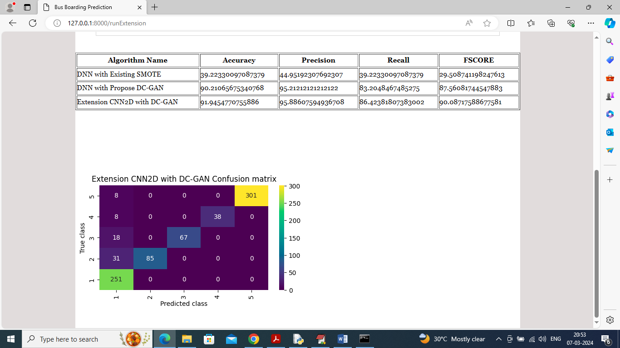
In above screen extension got 91% accuracy and can see other metrics also. Now click on ‘Comparison Graph’ link to get below graph
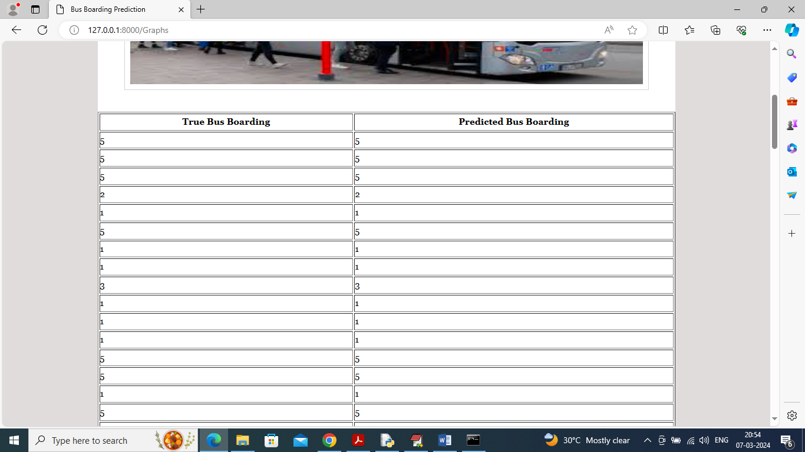
In above screen first column contains Test data boarding person count and second column contains Extension prediction boarding persons and scroll down above page to view below graph
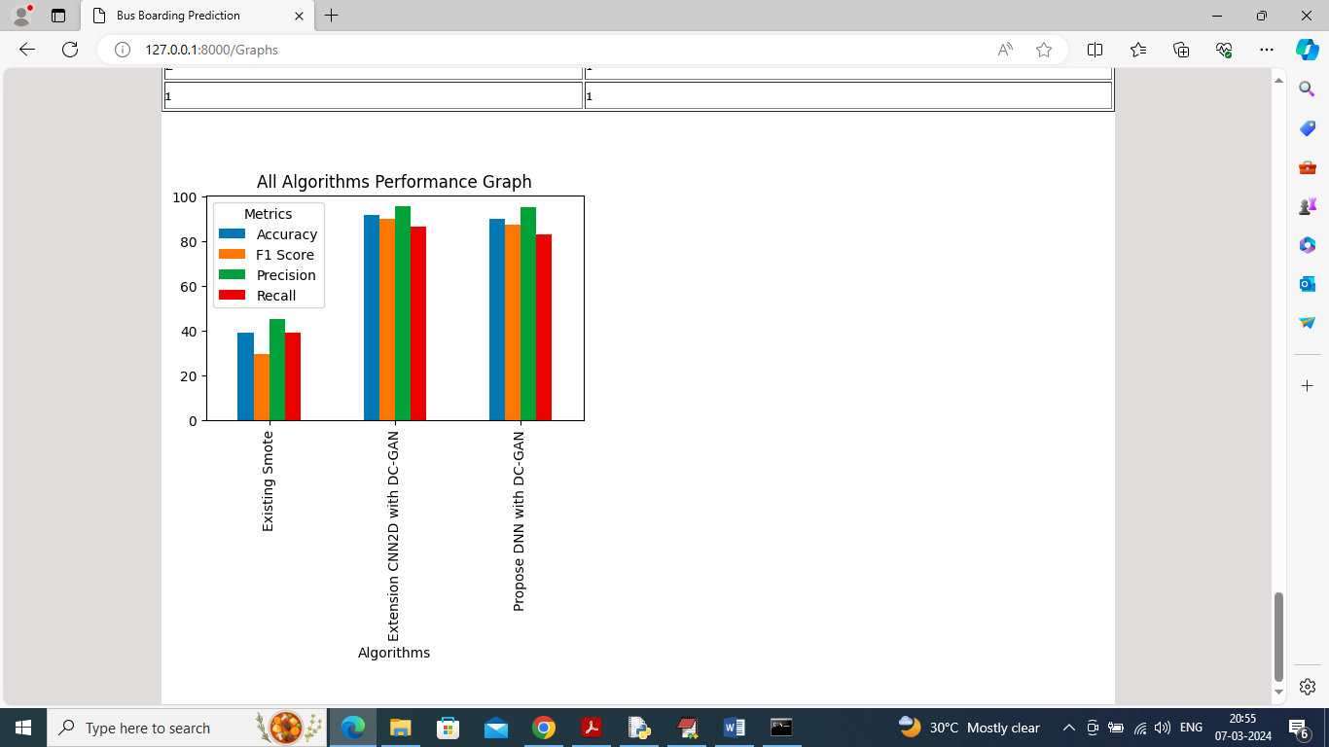
In above graph x-axis represents algorithm names and y-axis represents accuracy and other metrics in different bars and in all algorithms extension got high accuracy

8. CONCLUSION:
The motivation of this study was because we have faced the challenge of imbalanced data when we used the real world bus smart-card data to prediction the boarding behaviour of passengers at a time window. In this research, we proposed a Deep-GAN to over-sample the travelling instances and to re-balance the rate of travelling and non-travelling instances in the smart-card dataset in order to improve a DNN based prediction model of individual boarding behaviour. The performance of Deep-GAN was evaluated by applying the models on real-world smart-card data collected from seven bus lines in the city of Changsha, China. Comparing the different imbalance ratios in the training dataset, we found out that in general, the performance of the model improves with more imbalanced data and the most significant improvement comes at a 1:5 ratio between positive and negative instances. From the perspective of prediction accuracy of the hourly distribution of bus ridership, the high rate of imbalance will cause misleading load profiles and the absolutely balanced data may over predict the ridership during peak hours. Comparison of different resampling methods reveals that both over-sampling and under-sampling benefits the performance of the model. Deep GAN has the best recall score and its precision scores best among the over-sampling methods. Although the performance of the predictive model trained by the Deep-GAN-data is not significantly beyond other resampling methods, the Deep GAN also presented a powerful ability to improve the quality of training dataset and the performance of predictive models, especially when the under-sampling is not suitable for the data. The contributions of this study are: • The data imbalance issue in the public transport system has received little attention, and this study is the first to focus on this issue and propose a deep learning approach, Deep-GAN, to solve it. • This study compared the differences in similarity and diversity between the real and synthetic travelling instanced generated from Deep-GAN and other over-sampling methods. It also compared different resampling methods for the improvement of data quality by evaluating the performance of the next travel behaviour prediction model. This is the first validation and evaluation of the performance of different data resampling methods based on real data in the public transport system. • This paper innovatively modelled individual boarding behaviour, which is uncommon in other travel demand prediction tasks. Compared to the popular aggregated prediction, this individual-based model is able to provide more details on the passengers’ behaviour, and the results will benefit the analysis of the similarities and heterogeneities. As technology and computing power develop, predicting models will become more and more refined. In the field of demand prediction of the public transport systems, the target will gradually evolve from the bus network and bus lines to individual travel behaviour. This advancement can greatly benefit public transport planning and management, such as the digital twin of the public transport system. It is foreseeable that future prediction work in public transport systems will also encounter the challenge of imbalanced data. Our research proposes a Deep-GAN model to address the data imbalance issue in travel behaviour prediction. The validation via realworld data illustrated that the Deep-GAN showed a better ability to deal with the data imbalance issue and benefits the predictive models compared to other resampling methods. This research provides valuable experience for more researchers and managers in dealing with similar data imbalance issues, especially in public transport. It may be noted that despite the great performance of Deep GAN and DNN models, there are still some limitations. First, in this research, Deep-GAN is solely applied for the oversampling. However, there is also a hybrid variant of Deep GAN where positive instances are over-sampled and negative instances are under-sampled. The promising results of the Deep-GAN oversampling serve as a motivation to test the performance of the hybrid Deep-GAN in future research. Second, this study makes the prediction at the individual level, which creates an explosion of information and makes the computation more difficult. Classifying the passengers (using clustering methods for instance) may be useful in terms of reducing the size of the dataset. Third, the current Deep GAN does not consider the spatio-temporal characteristics of boarding behaviour. Customising the networks of generator and discriminator in GAN based on the characteristics of the boarding behaviour will further improve the quality of generated dummy travelling instances and the performance of the following predictive models. Finally, the proposed Deep GAN selected the features and variants of the data augmentation independently. So, the improvements are likely to be sub-optimal. Jointly selecting the features and the optimum imbalance ratio is likely to result in further improvements but at the cost of computational complexity. This can be tested in future. Similarly, the optimum rate of imbalance for Deep GAN has been assumed to be the optimum rate for other resampling methods. This assumption needs to be tested in future research. Even in its current form, this research demonstrates the extent of improvement offered by the Deep-GAN method in addressing the data imbalance issue in modelling boarding behaviour. By better predicting the boarding behaviour, the findings can help the public transport authorities to improve the level-of-service and efficiency of the public transport system. It can also be extended to other components of the public transport usage behaviour – better prediction of the alighting or transfer behaviour, for instance.

9. REFERENCES:
[1] X. Guo, J. Wu, H. Sun, R. Liu, and Z. Gao, “Timetable coordination of first trains in urban railway network: A case study of beijing,” Applied Mathematical Modelling, vol. 40, no. 17, pp. 8048–8066, 2016.
[2] W. Wu, P. Li, R. Liu, W. Jin, B. Yao, Y. Xie, and C. Ma, “Predicting peak load of bus routes with supply optimization and scaled shepard interpolation: A newsvendor model,” Transportation Research Part E: Logistics and Transportation Review, vol. 142, p. 102041, 2020.
[3] N. Besinovi ˇ c, L. De Donato, F. Flammini, R. M. Goverde, Z. Lin, R. Liu, ´ S. Marrone, R. Nardone, T. Tang, and V. Vittorini, “Artificial intelligence in railway transport: Taxonomy, regulations and applications,” IEEE Transactions on Intelligent Transportation Systems, 2021.
[4] S. C. Kwan and J. H. Hashim, “A review on co-benefits of mass public transportation in climate change mitigation,” Sustainable Cities and Society, vol. 22, pp. 11–18, 2016.
[5] Y. Wang, W. Zhang, T. Tang, D. Wang, and Z. Liu, “Bus od matrix reconstruction based on clustering wi-fi probe data,” Transportmetrica B: Transport Dynamics, pp. 1–16, 2021, doi: 10.1080/21680566.2021.1956388.
[6] S. J. Berrebi, K. E. Watkins, and J. A. Laval, “A real-time bus dispatching policy to minimize passenger wait on a high frequency route,” Transportation Research Part B: Methodological, vol. 81, pp. 377–389, 2015.
[7] A. Fonzone, J.-D. Schmocker, and R. Liu, “A model of bus bunching ¨ under reliability-based passenger arrival patterns,” Transportation Research Part C: Emerging Technologies, vol. 59, pp. 164–182, 2015.
[8] J. D. Schmocker, W. Sun, A. Fonzone, and R. Liu, “Bus bunching ¨ along a corridor served by two lines,” Transportation Research Part B: Methodological, vol. 93, pp. 300–317, 2016.
[9] D. Chen, Q. Shao, Z. Liu, W. Yu, and C. L. P. Chen, “Ridesourcing behavior analysis and prediction: A network perspective,” IEEE Transactions on Intelligent Transportation Systems, pp. 1–10, 2020.
[10] E. Nelson and N. Sadowsky, “Estimating the impact of ride-hailing app company entry on public transportation use in major us urban areas,” The B.E. Journal of Economic Analysis & Policy, vol. 19, no. 1, p. 20180151, 2019.
[11] Z. Chen, K. Liu, J. Wang, and T. Yamamoto, “H-convlstm-based bagging learning approach for ride-hailing demand prediction considering imbalance problems and sparse uncertainty,” Transportation Research Part C: Emerging Technologies, vol. 140, p. 103709, 2022.
[12] R. Liu and S. Sinha, “Modelling urban bus service and passenger reliability,” 2007.
[13] J. A. Sorratini, R. Liu, and S. Sinha, “Assessing bus transport teliability using micro-simulation,” Transportation Planning and Technology, vol. 31, no. 3, pp. 303–324, 2008.
[14] Y. Wang, W. Zhang, T. Tang, D. Wang, and Z. Liu, “Bus od matrix reconstruction based on clustering wi-fi probe data,” Transportmetrica B: Transport Dynamics, pp. 1–16, 2021.
[15] Y. Hollander and R. Liu, “Estimation of the distribution of travel times by repeated simulation,” Transportation Research Part C: Emerging Technologies, vol. 16, no. 2, pp. 212–231, 2008.
[16] W. Wu, R. Liu, and W. Jin, “Modelling bus bunching and holding control with vehicle overtaking and distributed passenger boarding behaviour,” Transportation Research Part B: Methodological, vol. 104, pp. 175–197, 2017.

